Compare the 74LS14 and 74HC14 datasheets. Look at the minimum required input voltage on pin 2 of the AT Mega 2560 CPU on the Arduino. Explain why the 74HC14 is better.

* (74LS14) Vcc range = 4.25 : 5.75 V.
* (74HC14) Vcc range = 2 : 6 V.
* (74LS14) Threshold Voltage = 2.3 : 3.15 V. (free air temp at 5 = Vcc)
* (74HC14) Threshold Voltage = 3.3 : 4.20 V. (free air temp at 5 = Vcc)
* (74LS14) Hysteresis Voltage = 838 : 811 mV. (free air temp at 5 = Vcc)
* (74HC14) Hysteresis Voltage = 0.6 : 1.4 V. (free air temp at 5 = Vcc)
* Pin 2 of the ATMega 2560 CPU in its TQFP configuration is the RX0/PCINT8 pin
* The minimum required input voltage for Pin 2 to be considered high is 3.5 V (.7*VCC)
* The 74HC14 is better because its range of Vcc’s are greater than that of the 74LS14, meaning that it can power the AT Mega 2560 which requires a Vcc range of 3.5 V.

Make a list of 3 things on your laptop that you think probably use an interrupt and explain why.

* The *save document* is probably an interrupt because it automatically interrupts the user’s ability to either close a text editor application or turn off their computer.
* The *low battery warning* is probably an interrupt because it automatically warns the user of the available energy regardless of what application or program they’re running.
* A *software update* is probably an interrupt because it automatically prompts the user to update their computer’s applications at set intervals regardless of what application or program is running.

Review the schematics and datasheets from the wheel encoders. They will be in the Sensors directory of the parts documentation. Review the signal diagram that is in the Sensors directory and explain in your prelab what it indicates about the operation of the wheel encoders.

* The signal diagram indicates that there is a slight delay between the input and output signal of the wheel encoders. This is delay is on the order of ~200 μs.

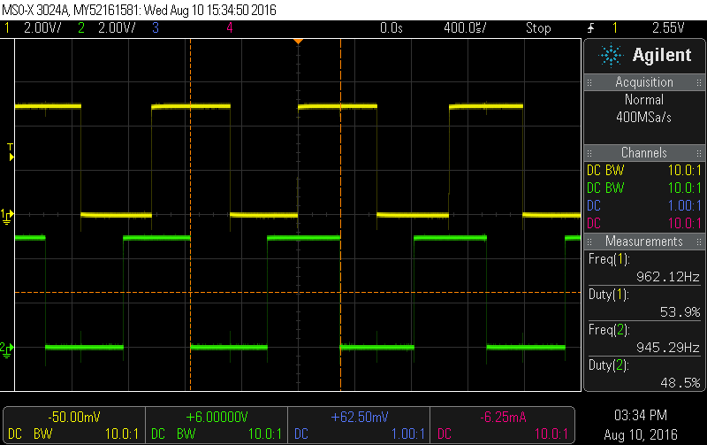

Make a list of the methods in the TimerOne library.

void initialize(long microseconds=1000000);

void start();

void stop();

void restart();

unsigned long read();

void setPeriod(long microseconds);

void pwm(char pin, int duty, long microseconds=-1);

void setPwmDuty(char pin, int duty);

void disablePwm(char pin);

void attachInterrupt(void (*isr)(), long microseconds=-1);

void detachInterrupt();

Include a selfie from your planning meeting where one of you holds the wheels up in front of your eyes so you look like an anime character. If you didn’t bring the wheels –find some other circles. Or take a selfie with a cow.



**Figure 1:** pre-lab selfie.